1. Install the Git
2. Go to the directory you want to make the GIT REPO

D:/Imp Notes for Interview**> Git init**

1. Create the new file and save it
2. **>Git status**

to check the status

1. **>Git add** chapter1.txt

This command add the file to the staging

1. Add the file to the repo by committing

**D:\Imp Notes for Interview>git commit -m "This is my First commit!"**

Make more changes and save the file and close it

**D:\Imp Notes for Interview>git commit -am "This is my second commit!"**

If don’t give –a on the second commit the changes wont be committed sometimes

To find the difference between the two files use the following command

**D:\Imp Notes for Interview>git diff "GIT HUb.docx"**

To roll back to the last commit give the following command

**D:\Imp Notes for Interview>git checkout "GIT HUb.docx”**

**GITHUB**

Create an account in <https://gits://github.com>

Login to the account.

Add a new repository

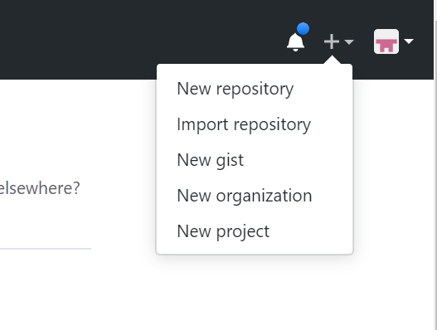

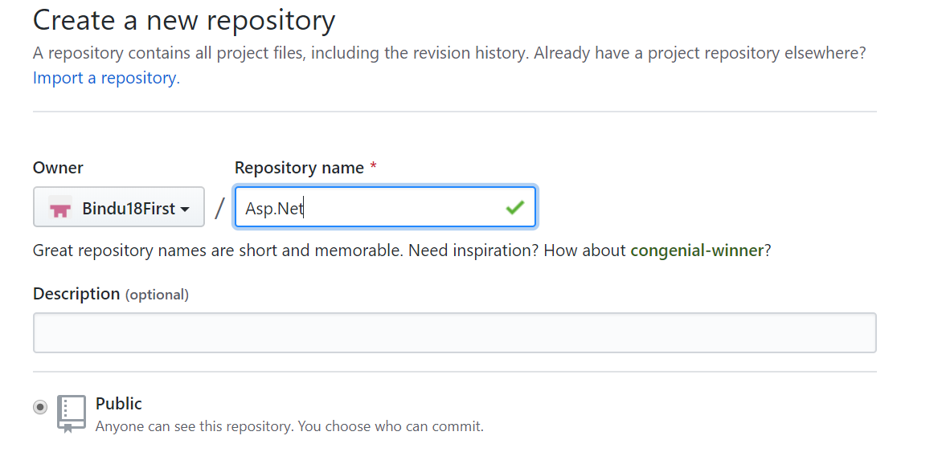

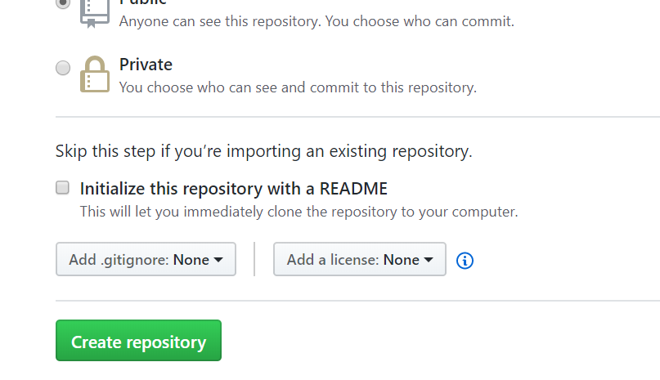

Create a the repository

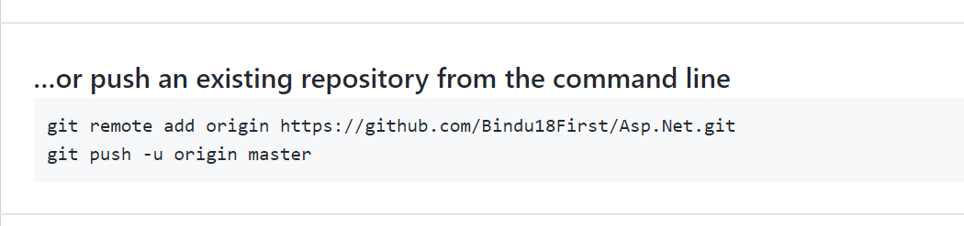

* git remote add origin https://github.com/Bindu18First/Asp.Net.git

>git push -u origin master

Command promt the local repo will be added to the GITHUB